Laboratoriya ishi №8

Fan: Web ilovalar

Mavzu: CSS Flexbox va Grid yordamida sahifa tartibini yaratish

1. Maqsad:
Veb sahifada Flexbox va Grid texnologiyalaridan foydalanib, bloklarning joylashuvini tartibga solish va moslashuvchan (responsive) dizayn yaratishni o‘rganish.

2. Nazariy ma’lumot

Flexbox (Flexible Box Layout)
Flexbox — bu bir o‘lchamli (bir yo‘nalishda) joylashuv tizimi bo‘lib, elementlarni gorizontal yoki vertikal yo‘nalishda oson joylashtirishga yordam beradi.
Asosiy xossalar:
display: flex; — konteynerni Flexboxga aylantiradi
justify-content — elementlarni gorizontal joylashtiradi
align-items — vertikal yo‘nalishda joylashtiradi
flex-wrap — elementlarni keyingi qatorga o‘tkazadi

Grid Layout
Grid — bu ikki o‘lchamli (qator va ustun) tartib tizimi bo‘lib, sahifani tarmoq shaklida joylashtirish imkonini beradi.

Asosiy xossalar:
display: grid; — konteynerni Grid tizimiga aylantiradi
grid-template-columns — ustunlar sonini belgilaydi
grid-template-rows — qatorlar balandligini belgilaydi
gap — qator va ustunlar orasidagi bo‘shliq

3. Amaliy qism

Fayl tuzilmasi:
/lab8/
│
├── index.html
└── style.css

index.html
<!DOCTYPE html>
<html lang="uz">
<head>
<meta charset="UTF-8">
<meta name="viewport" content="width=device-width, initial-scale=1.0">
<title>Xiva shahri</title>
<link rel="stylesheet" href="style.css">
</head>
<body>

<!-- HEADER -->
<header class="header">
<h1>Xiva shahri</h1>
<nav class="nav">
<a href="#">Bosh sahifa</a>
<a href="#">Tarix</a>
<a href="#">Diqqatga sazovor joylar</a>
<a href="#">Aloqa</a>
</nav>
</header>

<!-- MAIN CONTENT -->
<main class="container">

<!-- GRID SECTION -->
<section class="grid-content">
<div class="card">
<h2>Ichan-Qal’a</h2>
<p>Xivaning tarixiy markazi bo‘lib, 1990-yilda YuNESKO merosi ro‘yxatiga kiritilgan.</p>
</div>

<div class="card">
<h2>Kalta Minor minora</h2>
<p>Ko‘k-yashil koshinlar bilan bezatilgan, Xivaning eng mashhur me’moriy yodgorliklaridan biri.</p>
</div>

<div class="card">
<h2>Juma masjidi</h2>
<p>Ichki ustunlari bilan mashhur bo‘lgan qadimiy masjid — Xivaning ramzlaridan biri.</p>
</div>
</section>

<!-- SIDEBAR -->
<aside class="sidebar">
<h3>Foydali ma’lumotlar</h3>
<ul>
<li>Joylashuv: Xorazm viloyati</li>
<li>Asos solingan: mil.av. VI asr</li>
<li>Aholi: 90 mingdan ortiq</li>
</ul>
</aside>

</main>

<!-- FOOTER -->
<footer class="footer">
<p>© 2025 Xiva shahri haqida sahifa</p>
</footer>

</body>
</html>

SCC
body {
margin: 0;
font-family: Arial, sans-serif;
background: #f3f3f3;
}

/* HEADER (Flexbox) */
.header {
background: #0b4d4f;
color: white;
padding: 20px;
display: flex;
justify-content: space-between;
align-items: center;
}

.nav a {
color: white;
margin-left: 15px;
text-decoration: none;
font-weight: bold;
}

/* MAIN LAYOUT (Flexbox) */
.container {
display: flex;
padding: 20px;
}

/* GRID SECTION */
.grid-content {
flex: 3;
display: grid;
grid-template-columns: repeat(auto-fill, minmax(260px, 1fr));
gap: 20px;
}

.card {
background: white;
padding: 15px;
border-radius: 8px;
box-shadow: 0 0 10px rgba(0,0,0,0.1);
}

/* SIDEBAR (Flexbox) */
.sidebar {
flex: 1;
background: #ffffff;
margin-left: 20px;
padding: 15px;
border-radius: 8px;
height: fit-content;
box-shadow: 0 0 10px rgba(0,0,0,0.1);
}

/* FOOTER */
.footer {
text-align: center;
padding: 15px;
background: #0b4d4f;
color: white;
margin-top: 20px;
}
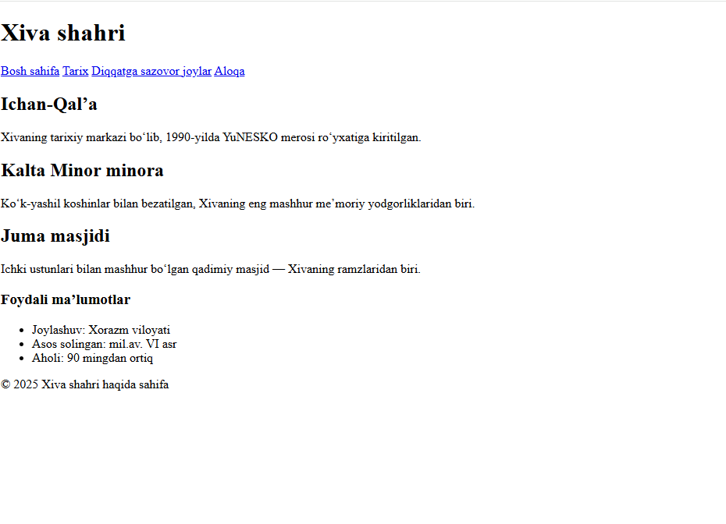

5. Xulosa
Ushbu laboratoriya ishida CSS Flexbox va CSS Grid texnologiyalaridan foydalanib, sahifadagi elementlarni tartibli va moslashuvchan joylashtirish usullari o‘rganildi.
Flexbox bir o‘lchamli (qator yoki ustun) tartib yaratishda qulay bo‘lsa, Grid ikki o‘lchamli (qator va ustun) tartibni shakllantirishda samarali hisoblanadi.

